Table of Contents

**Document Pg. No.**

1. Cover Sheet

2. Project Summary

3. Project Description

3.1. The Problem

3.1.1. Problem Introduction

3.1.2. Statistics

3.1.3. Increase of Mishandled Bags

3.1.4. Causes of Mishandled Luggage

3.1.5. An Expert’s Words

3.2. The Solution

3.2.1. Solution Introduction

3.2.2. The Five Checkpoints

3.2.3. Process Flow

3.2.4. Cart Antenna

3.3. The Market

3.3.1. Target Customers

3.3.2. Competition

3.3.3. Niche

3.3.4. Solution Characteristics

3.4 Evaluation Criteria

4. Biographical Sketches

4.1. Senior Personnel  *20*

4.2. Consultants and Experts

5. Budget

5.1. Phase 0 *22*

5.2. Phase 1 *24*

5.3. Phase 2

5.4. Phase 3 *25*

6. Facilities, Equipment, and Other Resources

6.1. Facilities *27*

6.2. Location *27*

6.3. Software *37*

6.4. Hard Resource  *28*

7. References Cited *29*

8. Appendices

8.1. Management and Organization Plan *I*

8.2. Marketing Plan *II*

8.3. Staffing Plan *III*

8.4. Funding Plan *IV*

8.5. WBS *V*

8.6. Risk Management Plan *VI*

8.7. Evaluation Plan



# 2. Project Summary

In spite of current quality assurance measures, airlines spend billions of dollars a year on mishandled luggage. This includes the funding to support the extra personnel to transport the bags to the individuals and also to reimburse travelers who’s bags have been lost. We seek to alleviate that cost.

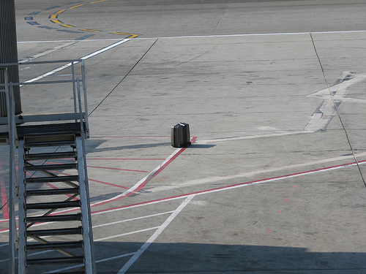

To solve this problem a better quality assurance system needs be placed. The system should have more checkpoints to pinpoint the exact location of errors. Since 61% of all mishandled bags are caused by transfers, areas involving transfers should be the main focal point.

AIR Tracker accomplishes all of the above and more. In addition to the checkpoints current quality assurance systems have (check-in and sorting), AIR tracker is able to track bags when they are loaded and unloaded from the cart which is crucial during transfers. Not only does the system track the bags, it can also sense when a bag has strayed away from the cart and can safely alert the driver. Furthermore, the cart scans would eliminate the need of scanning the bag at the bottom of the belt loader thus effectively reducing the time for all flights, including transfers.

1) In this case, “mishandled” means dropped, left behind, or mistakenly sent to the wrong area or plane.

# 3. Project Description

**3.1. The Problem**

**3.1.1. Problem Introdution**

Mishandled luggage costs the airline industry as a whole $4 billion a year. Returning mishandled luggage wastes the time of both customer and airline.

Customers can become frustrated after their bag is mishandled for several reasons. For example, if the customer is a on a business trip and has uniform inside his or her bag, that person may give a bad appearance and lose reputation. Or it may just be that the person needs necessities such as medicine or underwear.

Airlines also suffer from mishandled bags. They have to hire more personnel and buy more resources to remedy the problem. Mishandled luggage may even deter return customers.

**3.1.2. Statistics**

The following statistics from various organizations illustrate the magnitude of the problem.

* In July 2007 British Airways mishandled an average of 28 checked bags per 1000 passengers. - AEA (Association of European Airlines)
* In August 2008, bags were mishandled at a rate of 8,700 a day by American-based airlines. - U.S. Department of Transportation

“If an airline [mishandles] a passenger’s bag, you raise the possibility of losing the customer for the long term.” Billions in lost revenue and wasted man-hours takes away from the customer-oriented business of air travel.

**3.1.3. Increase of Mishandled Bags**

The problem isn’t stopping either. More people are flying, yet little has changed in the airport systems to handle the increase. The following graph exemplifies the increased rate of mishandled baggage by U.S. Airlines. Many other large airlines suffer from a similar increase.

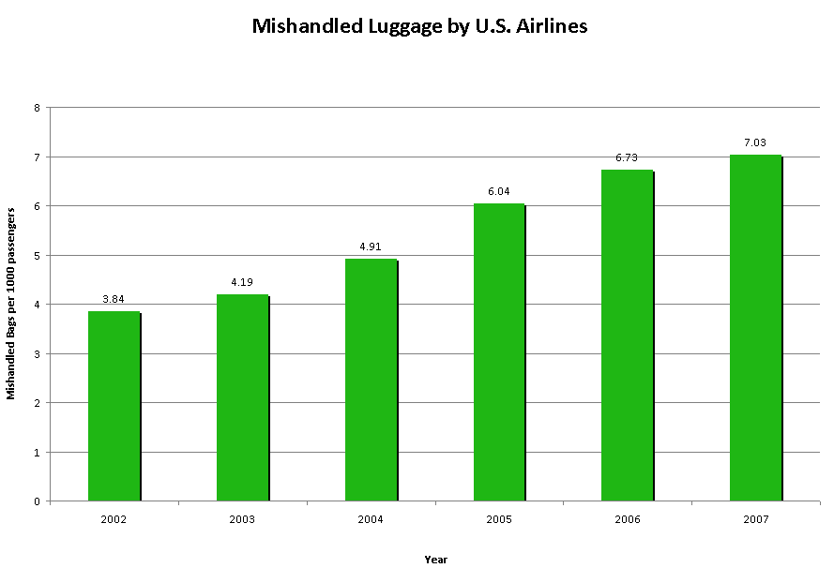

Along with the ever increasing population, more and more regulations are being placed which further attribute to the cause of increase in mishandled bags. Martin Broughton, ex-Chairman of British Airways, said “The government’s insistence on only one piece of hand luggage… has put huge strain on the baggage handling staff and, yes, is therefore to blame for the lost luggage.”

**3.1.4. Causes of Mishandled Luggage**

The graph below shows the percentage of mishandled bags grouped by the general cause. The numbers within this graph will be referenced upon frequently due to the importance of this data.

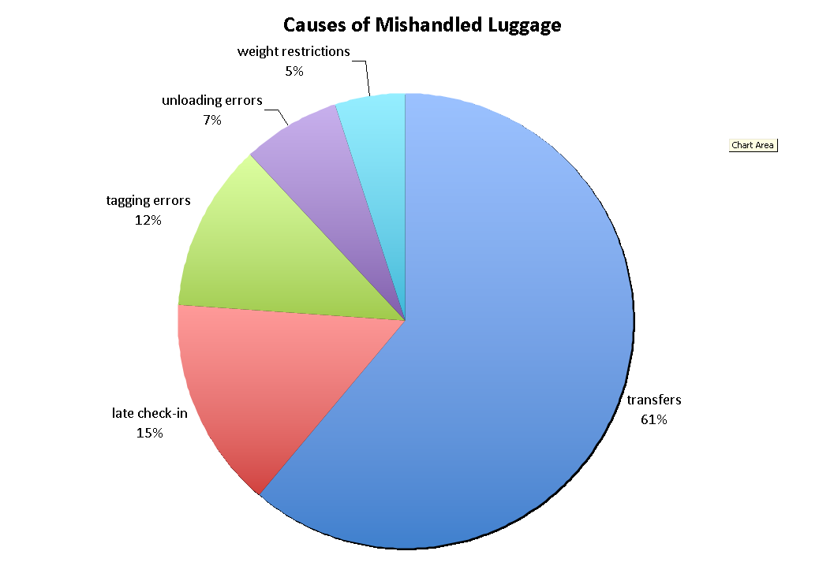

“The primary reason behind mishandled bags is delayed and misconnected flights.” said David A. Castelveter, an Air Transport Association spokesman. As you can see, over sixty percent of mishandled bags are indeed caused by transfers, followed by late check-ins, tagging errors, unloading errors and finally weight restrictions. Transfers are the biggest problem simply because there is not enough time to move the bag from one gate to another. Late check-ins would also delay the bag’s travel. Tagging errors are currently being fixed by replacing barcodes with RFID technology. Unloading errors can be fully amended with a good solution. Weight restrictions is the only cause of mishandled baggage that cannot be fixed.

**3.1.5. An Expert’s Words**

To find a more specific cause of mishandled baggage, team member Ashley Casper went to Norfolk International Airport to talk to Gloria Anderson, an expert in the baggage handling field. Of the many insights Mrs. Anderson had give us, these quotes were critical.

* “Baggage handlers drop more bags [off a cart] than they put baggage on the wrong flight.”
* “We’ll never know how many bags, when found to be missing from a flight, make it onto the right plane. Those statistics aren’t calculated.”
* “The carry-on versus checking issue is becoming more important because people are cheap. They refuse to check bags, but now, airlines can get fined thousands of dollars if a passenger carried more than two carry-ons onto a plane.

With these quotes, one can assume there is no scanning at the belt loader. Also, it is clear that bags that fall off the cart are a problem.

**3.2 The Solution**

**3.2.1. Solution Introduction**

A custom-suited AIR Tracker will augment existing systems at airports utilizing technology that already exists. Using the existing RFID antennae and bar code scanners that register the bag’s location, AIR Tracker will track and report on the routing of luggage in airports as well as offer a real-time account of luggage statistics on the luggage carts. AIR Tracker will provide comprehensive reports to assist the airport in pinpointing problem areas in their handling process, thereby reducing the amount of mishandled luggage.

SITA’s CEO, Francesco Violante once said, “Even small improvements in the amount of baggage ending up at the right place at the right time could save the air transport industry hundreds of millions of dollars a year as well as millions of passenger hours that could have been spent doing something much more productive than trying to retrieve mishandled bags.” AIR Tracker is a tool that is used to find trouble spots where “small improvements” can be made.

Air Tracker solves a lot of problems, but there are some things we do not intend to cover. We don’t provide personnel to manage the system, we only provide training. Also, our solution cannot be liable for any stolen bags.

**3.2.2. The Five Checkpoints**

AIR Tracker uses five well placed checkpoints to gather data.

1. Check-In
2. TSA Inspection
3. Loading the pusher
4. Unloading the pusher/Loading the cart
5. Unloading the cart (bottom of the belt loader)

The first three checkpoints will be provided from the existing baggage handling system while checkpoint 4 and 5 provided by us with the use of cart sensors and wireless antennas.

The following picture illustrates the five checkpoints.

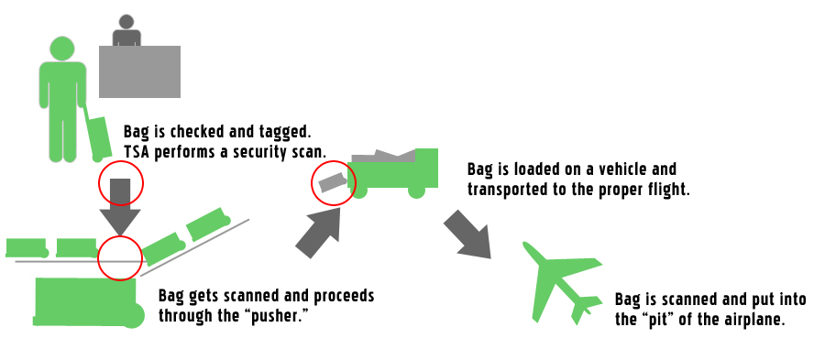

**3.2.3. Process Flow**

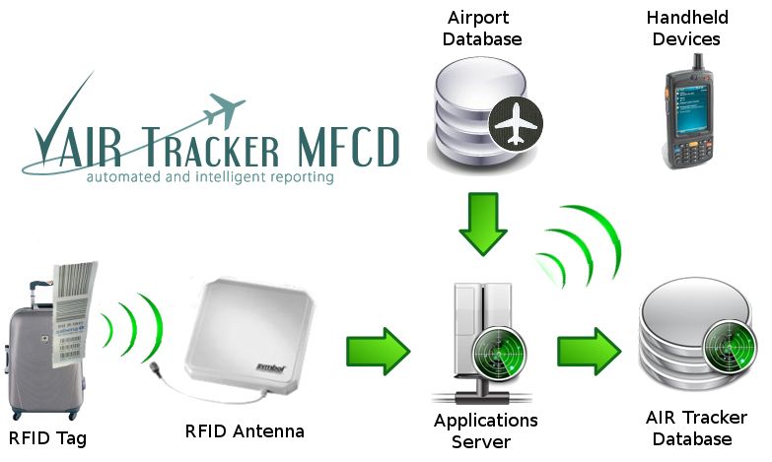

The diagram above displays the flow of data throughout major components of the project.

When a bag passes through a checkpoint, it is scanned by a RFID or barcode scanner. The data is then sent to an applications server via high speed Ethernet cables. The applications server continuously gathers data from both the airport database and antennas. At this point, the server may be used to send real-time alerts to other devices about mishandled bags. It then combines the data to create useful information and stores it in the AIR Tracker Database.

**3.2.4. Cart Antenna**

If a bag is dropped from the cart, it is not noticed until the cart reaches the airplane, which by that point (depending on the size of the airport), it may be too late to go back and get it before the plane departs.

The RFID baggage cart antenna communicates wirelessly (via WiFi) with the Airport’s WiFi antenna to gain updates from the master database on which bags should be on which flight. The cart also has onboard memory and firmware to temporarily store the data of the bags in the cart. The RFID Cart antenna actively pings the RFID tags on the bags in a cluster method. If one of the bags is returning a distinctly longer ping response, the antenna alerts the driver that a bag has fallen off. The driver then has time to stop and regain the dropped bag.

An RFID gate on the ramp reads the bags that are loaded on the airplane and sends an alert to the handlers if there is a bag that is not meant to be on that plane. The gate is updated wirelessly from the airport as well. This serves as a final redundancy to the RFID system.

**3.3 The Market**

**3.3.1. Target Customers**

Airports of all sizes can benefit from AIR Tracker, but the primary targets are airline hubs with RFID. An airline hub is an airport that an airline uses as a transfer point to get passengers to their intended destination. This is an airport where many transfers take place and where many bags are mishandled. To further specify the target, hubs with high rates of mishandled bags.

Since AIR Tracker is targeted at airports, the team will utilize personal marketing visits in order to market the product. The team would have to negotiate with the heads of the airport who would in turn talk to the airlines. The cost for the product would be shared by airlines and shops and other airport venues via higher lease fees.

Smaller airports will be used for beta testing. Success at these sites will entice larger airports to purchase AIR Tracker. The team can then try to get sponsored from large organizations to further advertise our success.

**3.3.2. Competition**

After we analyzed the current market for a drowning detection system such as ours, we then looked at our potential competitors. FKI Logistex, Logan Teleflex, and Vander-Lande all provide baggage handling systems along with software that allows the customer to see the status of a bag using the bare three checkpoints. Although the competition helps to solve each facet of the mishandled luggage problem, AIR Tracker supplements their capabilities.

WorldTracer on the other hand offers a comprehensive airline information management system for mishandled property, similar to the AIR Tracker. This makes WorldTracer our main competitor and also makes competition a huge risk.

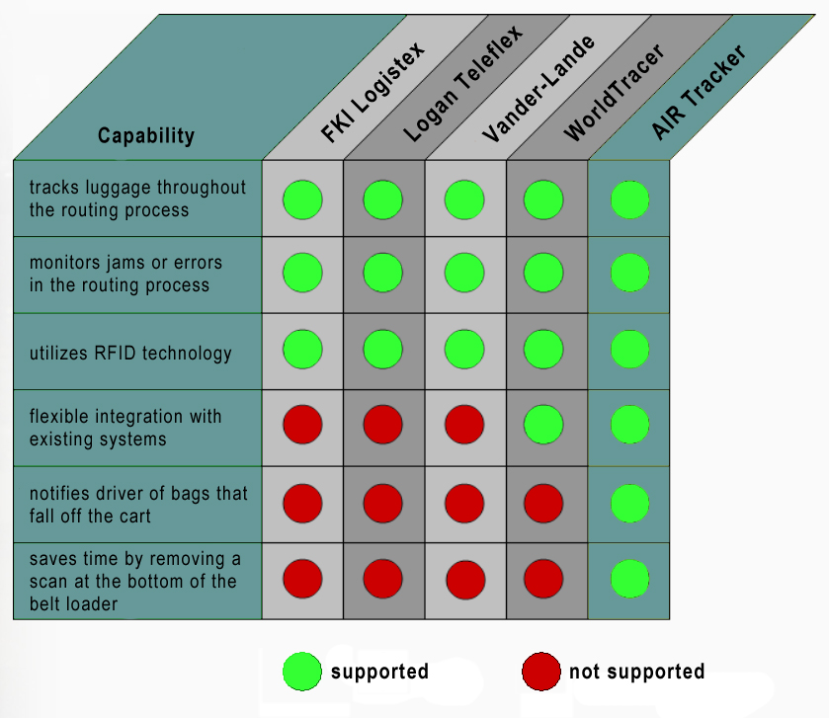

**3.3.3. Niche**

AIR Tracker rises above the competition mainly due to the three features shown above. Along with WorldTracer, AIR Tracker is able to integrate into existing systems with minimal modifications. It will be custom made for each airport. The two features that none of the competition has revolves around the cart module. The first feature being the notification to personnel when a bag has fallen of the cart and the second being the time saved by removing the bottom belt scan.

**Product Potential**

* The cost of returning a mishandled bag to its owner, including fuel, manpower, and ground transportation costs, is estimated at around $90 by the International Air Transport Association.1 Airlines currently lose approximately seven bags per 1000.
* Southwest Airlines, for example, flies over 104 million passengers a year.2
* That would conservatively equal approximately 728,000 mishandled bags a year, costing $65.5 million.
* If only three bags were lost per 1000, airlines would save almost $40 million.
* Saving one bag in 1000 saves almost $10 million.

**3.3.4. Solution Characteristics & Benefits**

To summarize the solution all of the benefits of AIR tracker are listed below.

AIR Tracker will…

* be able to integrate with any existing system and airport layout
* report on the status of any bag in real-time
* provide comprehensive reports of historical data
* identify bags that have gone off track
* identify and alert bags that have fallen off the cart
* pinpointing trouble spots in current baggage handling system
* reduce time for all flights
* significantly reduce time for transfers (two scans are eliminated)

**3.4. Evaluation Criteria**

Our project will be broken up into 4 phases: phase 0 (project inception), phase 1 (product prototyping), phase 2 (product design), and phase 3 (product out years).

For project phases 0 and the first half of phase 1, the team will meet weekly to collaborate about the project’s idea, feasibility, prototype, and future milestones. Throughout the course, our project we will be closely monitored by professor Janet Brunelle. Along with the professor, we will get constructive criticism from an expert panel.

During phase 0, our goal is to plan for the next three phases and follow through with a SBIR proposal. During the first half of phase 1 the team will work on the prototype in the ODU labs, and develop deliverables such as production specifications and the business plan. Then we use the SBIR grant to develop a prototype and move on to the phase 2 SBIR proposal.

For phase 2 we continue working on the prototype until we have a fully functional final product. During this phase we produce contracts, management plan, personnel plan, test and evaluation plan, marketing plan. Most of the software coding and hardware implementation is done in this phase.

Finally for phase 3, we advertise our product, get contracted and customize it for the airport.

7. References Cited

**Baggage Handling Facts**

1) “Air Travel Consumer Reports for 2008.” airconsumer.ost.dot.gov. 30 JUL2008. Office of Aviation Enforcement. 01 Oct 2008 <http://airconsumer.ost.dot.gov/reports/atcr08.htm>.

2) “Airport IT Trends Survey 2008.” sita.aero*.* SITA. 21 Oct 2008 <http://www  
 .sita.aero/News_Centre/Industry_surveys_and_trends/Airport_IT_trends  
 /default.htm>.

3) Bevan, Judi. “Coping with crisis, climate change — and lost luggage.”  
 spectator.co.uk. 07 Nov 2007. The Spectator. 20 Oct 2008 <http://ww  
 w.spectator.co.uk/the-magazine/business/334921/coping-with-crisis-cli  
 mate-change-and-lost-luggage.html>.

4) Bicknell, David. “Airlines reject RFID as universal industry solution to  
 lost bags.” ComputerWeekly.com. 30 Jul 2008. Computer Weekly. 20  
 Oct 2008 <http://www.computerweekly.com/Articles/2008/06/20/2311  
 41/airlines-reject-rfid-as-universal-industry-solution-to-lost.htm>.

5) “Frequently Asked Questions.” globalbagtag.com. Global Bag Tag. 20  
 Oct 2008 <http://www.globalbagtag.com/faq.cfm>.

6) Halthore, Mukund. “RE: Contact request from website (Germany).” Email to   
 Joel Elixson concerning the wholesale cost of GPS/GSM modules. 21 Oct  
 2008.

7) “IBM System x3450.” IBM. 2008. IBM. 21 Oct 2008 <http://www-304.ibm.co  
 m/shop/americas/webapp/wcs/stores/servlet/default/CategoryDisplay  
 ?categoryId=4611686018425232005&storeId=1&catalogId=-840&langId=  
 1>.

8) James, Andrea. “Seattle firm sues British Airways over lost luggage.”  
 Seattle PI. 13 Nov 2007. Seattle PI. 21 Oct 2008 <http://seattlepi.nwso   
 urce.com/business/339434_lostluggage13.html>.

9) “Job Salaries-Performance Reviews-Compensation software- Salary.com.”   
 2008. Salary.com. 04 Nov 2008 <http://www.salary.com>.

10) Levy, Francesca. “The Airlines’ Bag Reflex.” BusinessWeek.com. 30 Jul  
 2008. Business Week. 20 Oct 2008 <http://www.businessweek.com/life  
 style/content/jul2008/bw20080729_355085.htm>.

11) Mummolo, Jonathan. “Now Arriving At Carousel 1, Far Fewer Of Your  
 Bags.” Washingtonpost.com. 01 Oct 2007. Washington Post. 20 Oct 20  
 08 <http://www.washingtonpost.com/wpdyn/content/article/2007/09   
 /30/AR2007093001653.html?sid=ST2007100200809>.

12) Scottberg, Erin. “Anatomy of Lost Luggage: How to Track Your Bags  
 (and Save ’Em).” Popular Mechanics. 20 Dec 2007. Popular  
 Mechanics. 21 Oct 2008 <http://www.popularmechanics.com/technolo   
 gy/transportation/4237628.html>.

13) “Software Engineer / Developer / Programmer Job Salaries in Virginia  
 Beach-Norfolk-Newport News, VA-NC.” PayScale. 2008. 21 Oct 2008   
 <http://www.payscale.com/af/calc.aspx?job=program mer&city=Norfo   
 lk&state=VA>.

14) “IB Technology 125 kHz RFID Antenna.” Trossen Robotics. 2008. Trossen   
 Robotics. 04 Nov 2008 <http://www.trossenrobotics.com/ib-technology-  
 125-khz-rfid-antenna.aspx?feed=Froogle>.

**4.1. Senior Personnel**

**Jeremey Sellen, Project Manager**

Originally from Erieville, New York, Jeremey graduated from Cazenovia High School and has been in the Navy for ten years. His work includes many technical positions, mainly in systems administration and network operation and administration. Jeremey has also worked as a mid-level manager for thirty personnel and has a working knowledge of computer hardware and a more extensive knowledge in networking and computer programming. In his spare time he likes to read and spend time with his family.  
  
Jeremey's strengths are in C++, networking concepts and design, and personnel leadership.



**Rahil Patel, Marketing Specialist and Statistical Analysis**



Rahil is currently a senior attending Old Dominion University, where he will earn a bachelor's degree in computer science and a minor in computer engineering. So far throughout his studies, he is most interested in web programming. He will graduate in spring 2009 and pursue a job in the field. During his spare time he helps his dad with his hotel business and enjoys all forms of entertainment, including music, games, movies, and books.  
  
Rahil's strengths are in C++, PHP, MySQL, and Oracle.

**Alex Hitchens, Risk Analyst and Software Specialist**



Alex is originally from Williamsburg, Virginia and now lives in Virginia Beach, Virginia. He currently works at the Monarch Techstore doing various tasks from basic sales to computer support. His life goal is to someday intern and eventually work for a game company out West. In his spare time he loves to listen to music and code software. He also enjoys watching bad horror movies and has two cats, Professor Penelope and Mr. Bo.  
  
Alex's strengths are programming and logic puzzles.

**Neil Monday, Financial and Software Specialist**

Neil grew up in Richmond, Virginia and has lived there most of his life. He also spent a year in Geneva, Switzerland during his junior year of high school. His biggest hobbies are riding bikes, playing with his two dogs, and writing open-source software. For three years he worked for ODU's ResNet, helping to fix computers for on-campus students. For one year he worked for Alcoa Howmet as a computer programmer and learned about Visual Basic and various databases. He is now currently employed by xTuple as a C++/PostgreSQL programmer.  
  
Neil's strengths are in SQL (PostgreSQL and MySQL), C++, and PHP.



**Joel Elixson, Hardware and Software Specialist**



Joel is currently pursuing a bachelor's degree in computer science with a minor in modeling and simulation. He expects to graduating in May 2009. Joel's interests include computer graphics, biology, and applied mathematics. He is currently interning as a software and process engineer with Northrop Grumman. When he's not too busy working, he enjoys extreme ironing.  
  
Joel's strengths are in C, C++, Objective-C, OpenGL, Java, and SQL.

**Ashley Casper, Documentation and Website Specialist**

Ashley was born and raised in the Tidewater, Virginia area and has held a wide variety of interests throughout her educational "career." Starting as a journalist, she studied English and creative writing before finding a passion in website design and development. Ashley earned an associate's degree in web and graphic design and was trained in industry-standard visual and print media software in 2006. Deciding to finish her bachelor's degree at Old Dominion University, she turned to computer science and will graduate in the summer semester of 2009. In her spare time Ashley likes to play and watch basketball, write, study foreign languages and cultures, and create websites and graphics.  
  
Ashley's strengths include print and screen media design and implementation, HTML, Flash, and organization and leadership.

**4.2. Consultants**

**Professor Janet Brunelle – General Consultant**

Professor Janet Brunelle received her Bachelors of Science degree in Computer Science from Old Dominion University in 1980 and her MS in Computer Science from Old Dominion University in 1987.



**Dr. Michele Weigle – Wireless Network Expert**

Michele Weigle's current research interests are in Internet congestion control, network protocol evaluation, network simulation, wireless and mobile networks, and inter-vehicular communication.



Dr. Weigle's current research projects include: assisting in the development of the ns-2 and ns-3 network simulators, investigating proposals for high-speed TCP transfer, developing realistic traffic generators for network simulators, developing an inter-vehicular communication system, and investigating transport protocols for wireless sensor networks.

Dr. Weigle received her Ph.D. from the University of North Carolina in 2003. Before joining ODU, she was an Assistant Professor at Clemson University.

**Gloria Anderson – Handling and Airline Expert**



Gloria Anderson has been working for the airlines for over 15 years and has seen luggage procedures inside and out. Her many years of experience make her an important asset for information on the airport system as well as the baggage system itself. During phase 0 much of her information was vital to nailing down exactly what was wrong with the current system and what we could do to fix it.